Milestone 3:

* Create a UI Page/Panel for connecting to the server

1. **Username**
2. **Password (tentative)**
3. **Host**
4. **Port**

* Create a UI Page for the chatroom

1. List of users in the room Text area for the chat history
2. Input field for typing messages
3. Button for sending messages
4. Pressing enter should also submit the button if the input field isn't empty

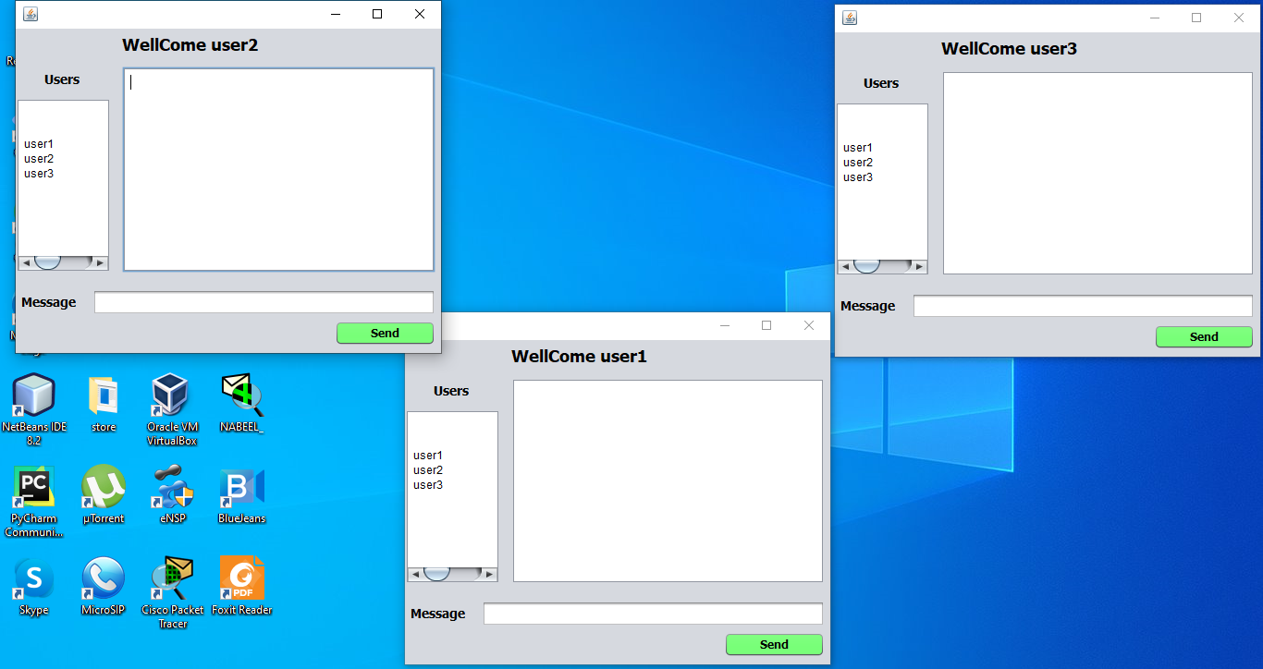

* Results from /flip and /roll appear in a different format than regular chat text
* Custom text display functions appear correctly in the chat area

* Messages that precede with @username will send the message privately to the user denoted by the username

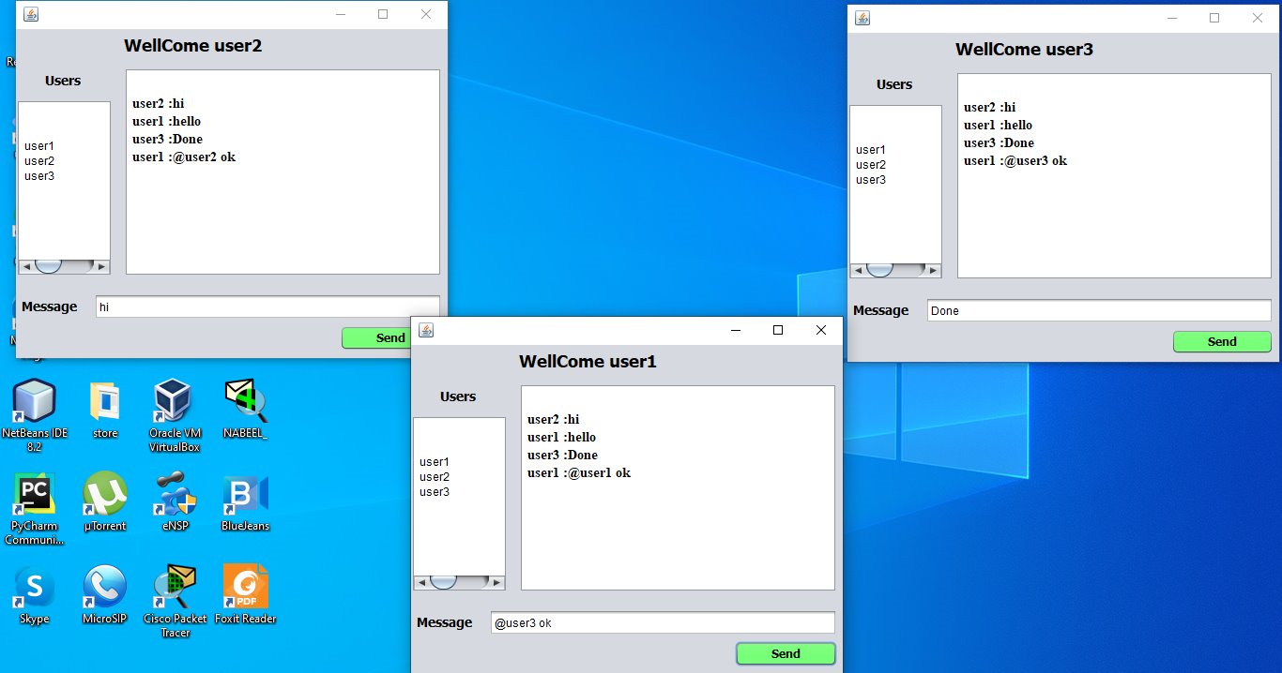

* The writer and the receiver are the only two that will receive the message from the server It's not valid to just hide it on the client side (i.e., data must not be sent from the server)
* The following commands will be implemented

1. mute @username
   1. Prevents the user from receiving messages from the denoted user

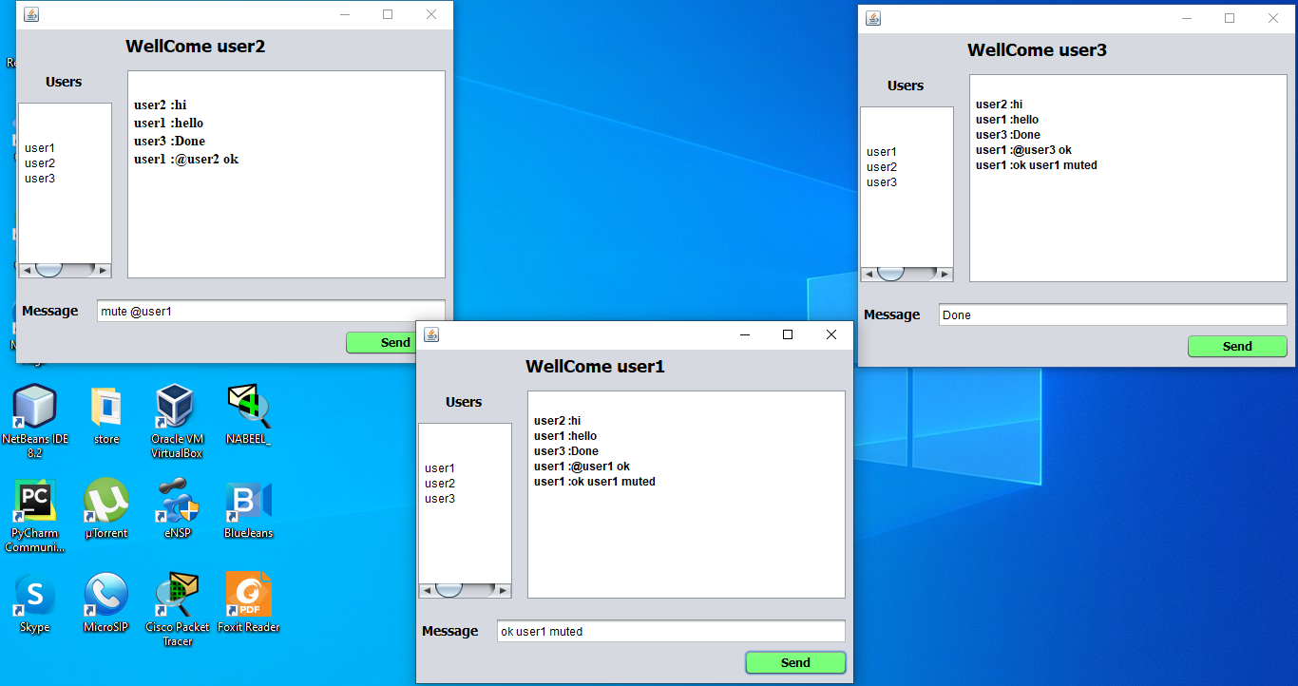

1. unmute @username
   1. Allows the user to receive messages from the denoted user (if they were previously muted)

